**DAILY ONLINE ACTIVITIES SUMMARY**

|  |  |  |  |  |  |  |  |  |
| --- | --- | --- | --- | --- | --- | --- | --- | --- |
| **Date:** | **01-6-2020** | | | | | **Name:** | **Likhitha.M** | |
| **Sem & Sec** | **6th sem ‘A’** | | | | | **USN:** | **4al17cs046** | |
| **Online Test Summary** | | | | | | | | |
| **Subject** | | **Cryptography, Network security and Cyber law** | | | | | | |
| **Max. Marks** | | **60** | | **Score** | | | **48** | |
| **Certification Course Summary** | | | | | | | | |
| **Course** | **Steps in Robotic Process Automation** | | | | | | | |
| **Certificate Provider** | | | **GUVI** | | **Duration** | | | **3 hours** |
| **Coding Challenges** | | | | | | | | |
| **Problem Statement:**  1.Python Program to remove duplicate elements from a list  2.Write a Java Program to left rotate the elements of an array.Problem Description In this program, we need to rotate the elements of an array towards the left by the specified number of times. In the left rotation, each element of the array will be shifted to its left by one position and the first element of the array will be added to end of the list. This process will be followed for a specified number of times. Suppose if n is 1 then, all elements of the array will be moved to its left by one position such that second element of the array will take the first position, the third element will be moved to the second position and so on. The first element of the array will be added to the last of the array.  3.Given an array of positive integers. Write a C Program to find the leaders in the array.  **Input:** The first line of input contains an integer T denoting the number of test cases. The description of T test cases follows. The first line of each test case contains a single integer N denoting the size of array. The second line contains N space-separated integers A1, A2, ..., AN denoting the elements of the array.  **Output:** Print all the leaders. **Constraints:** 1 <= T <= 100 1 <= N <= 107 0 <= Ai <= 107 | | | | | | | | |
| **Status: completed** | | | | | | | | |
| **Uploaded the report in Github** | | | | | **yes** | | | |
| **If yes Repository name** | | | | | **https://github.com/likhithaMantaral/Daily-status** | | | |
| **Uploaded the report in slack** | | | | | **yes** | | | |

Online test Details:

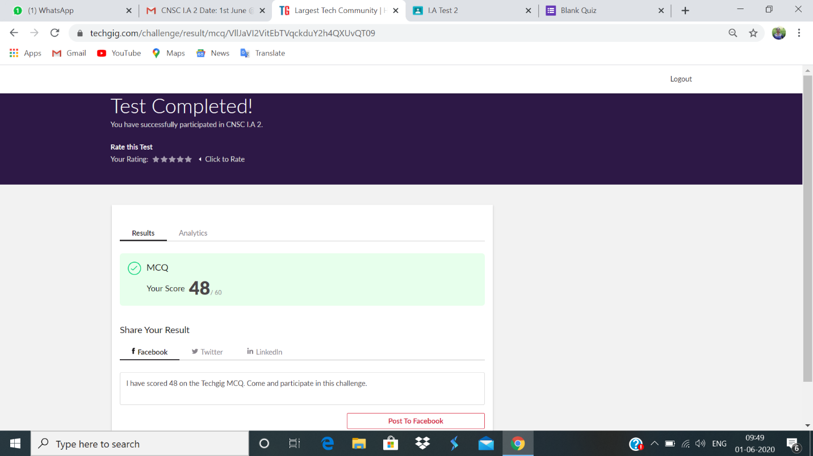

Certification Course Details:

**STEPS IN ROBOTIC PROCESS AUTOMATION**

Successfully completed the course

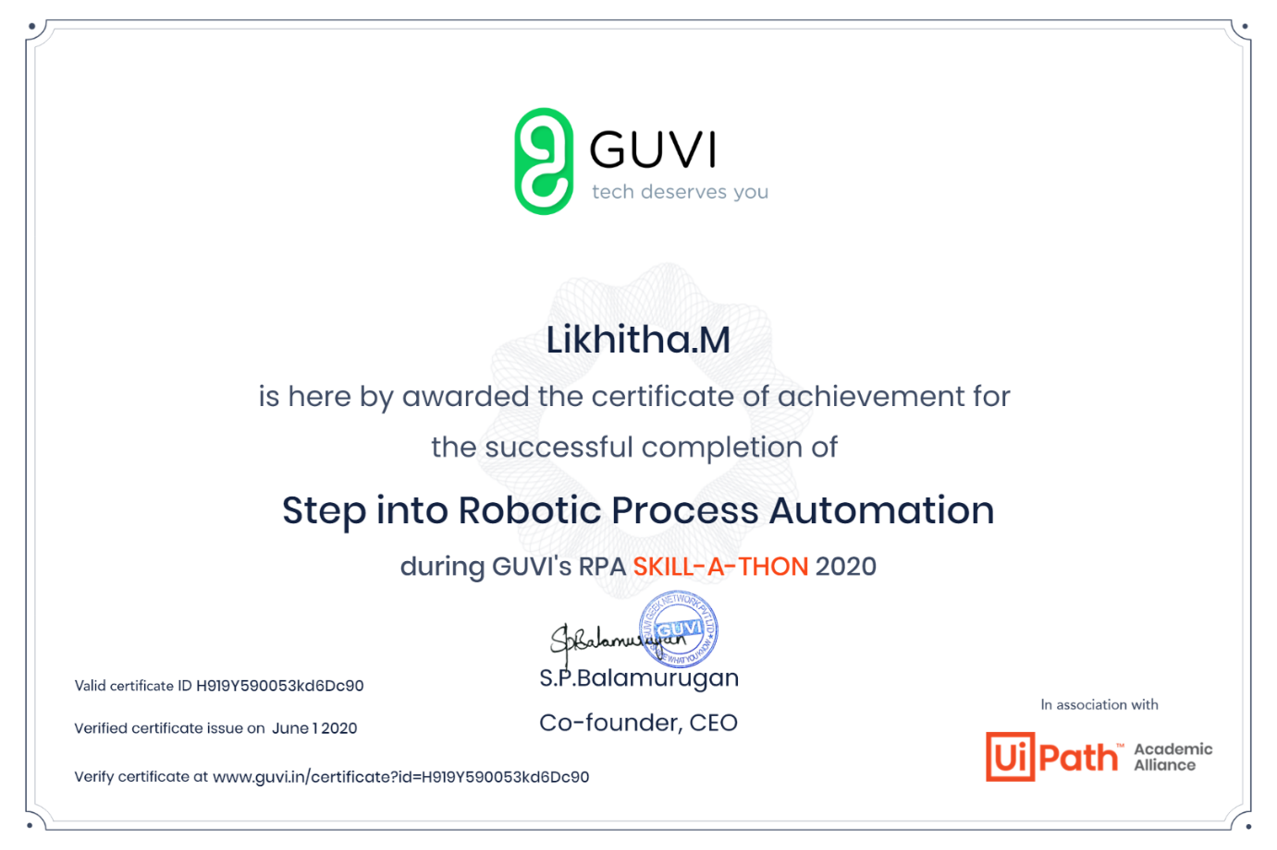

**Coding challenges:**

**1.**

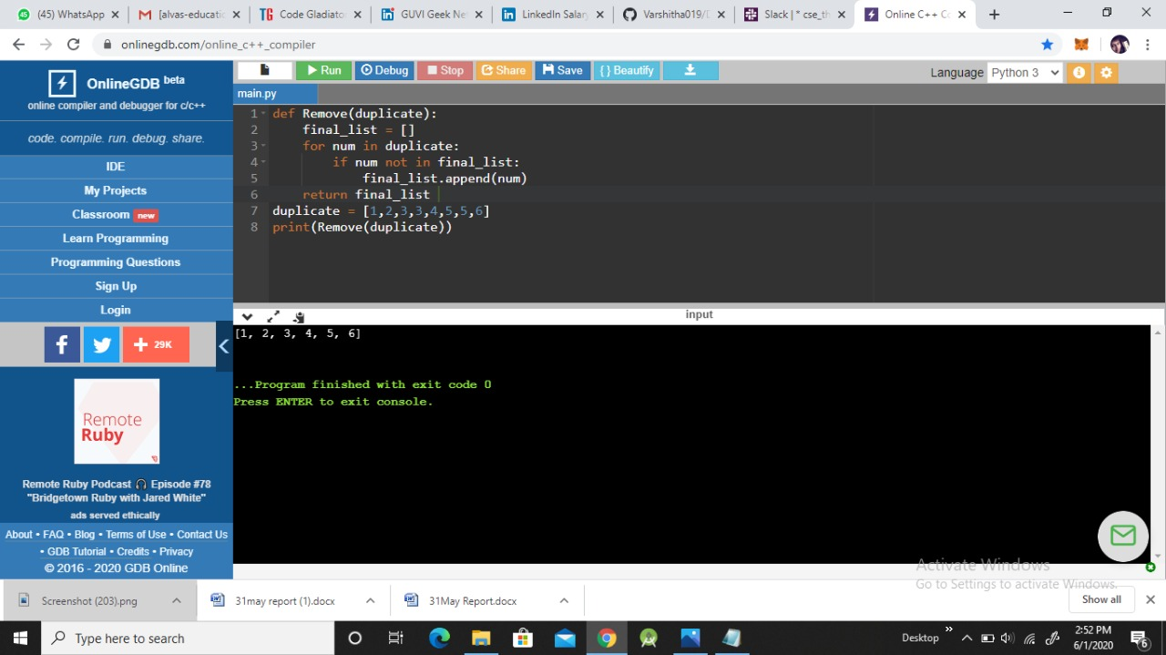

2.

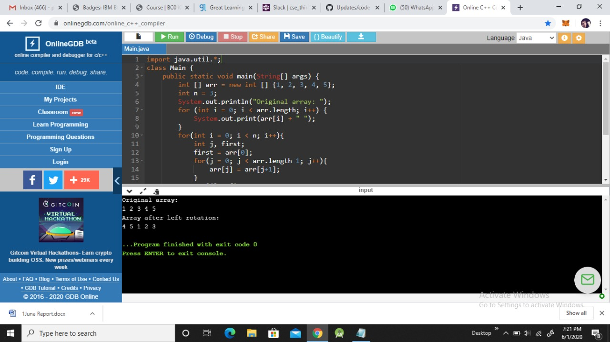

3.

